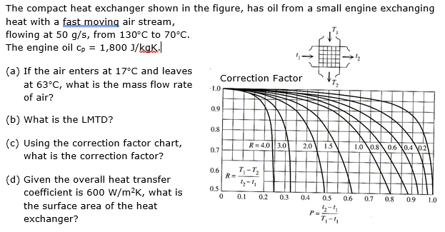

Ans: a) 0.028 kg/s; b) 60.9°; c) 0.93; d) 0.159 m2: change the colour of the white text below to reveal the method.

1. a) The capacity rate of the oil and the temperature change can be used to find the heat transferred in the heat exchanger. Therefore the air receives the thermal energy that is transferred as heat and it can be used together with the known temperature change to work out the mass flow rate:

Capacity rate of oil: $C_{oil}={\dot{m}}_{oil}c_{p,oil}=0.05×1800=90 W/K$

Heat transfer = thermal energy lost by the oil: $\dot{Q}=C_{oil}∆T_{oil}=90×\left(130-70\right)=5400 W$

Thermal energy gained by water = heat transfer: ${\dot{m}}_{water}c_{p,water}∆T_{water}={\dot{m}}_{water}×4180×\left(63-17\right)=5400→{\dot{m}}_{water}=\frac{5400}{4180×46}=0.028 kg/s$

1. LMTD is calculated by the formula with counter flow configuration so we can then use the chart subsequently:
$$∆T_{mean}=\frac{∆T_{a}-∆T_{b}}{ln{∆T_{a}}/{∆T_{b}}}=\frac{\left(130-63\right)-\left(70-17\right)}{ln{\left(130-63\right)}/{\left(70-17\right)}}=\frac{67-53}{ln{67}/{53}}=\frac{14}{0.23}=60.9$$

2. To use the chart, work out P and R, choice of T and t is arbitrary – it will work out whichever way you do it:

$$R=\frac{T_{1}-T_{2}}{t_{2}-t_{1}}=\frac{130-70}{63-17}=1.3$$

And:

$$P=\frac{t_{2}-t_{1}}{T_{1}-t_{1}}=\frac{63-17}{130-17}=0.41$$

Plotted in red.

Or:

$$R=\frac{T_{1}-T_{2}}{t_{2}-t_{1}}=\frac{17-63}{70-130}=0.77$$

And:

$$P=\frac{t_{2}-t_{1}}{T_{1}-t_{1}}=\frac{70-130}{17-130}=0.53$$

Plotted in green.

Plot on the chart to get correction factor, f:

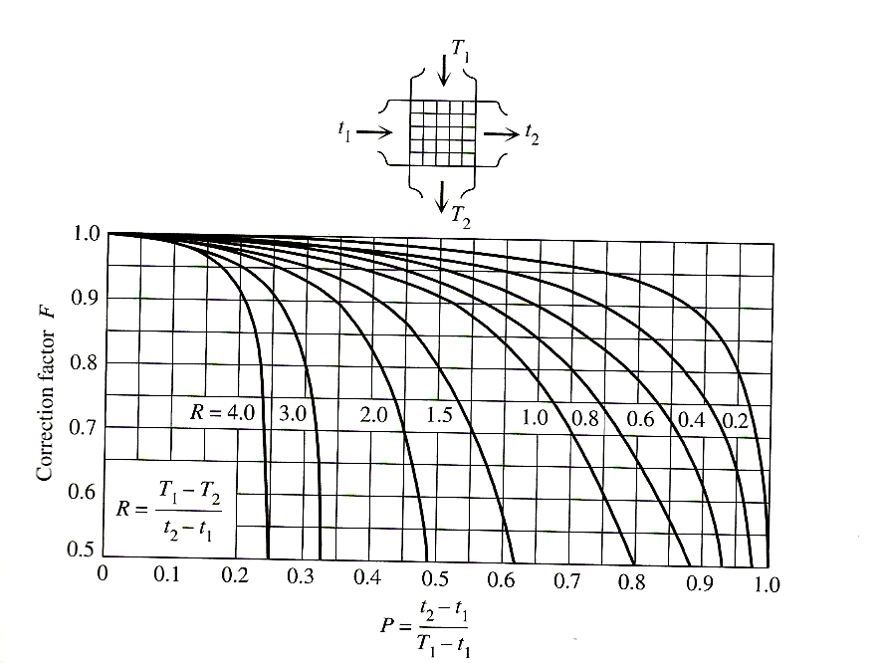

The cross over of the R and P lines is the same for both cases on the chart, approximately 0.93.

1. Surface area is what the LMTD calculation is best at. Use the LMTD and the known heat transfer to calculate the surface area using the formula:

$$\dot{Q}=UAf∆T_{mean}→5400=600×A×0.93×60.9:A=0.159 m^{2}$$

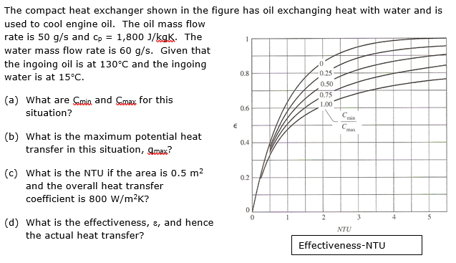

Answers: a) 90 W/K, 250.8 W/K; b) 10350 W; c) 4.44; d) 0.359, 9522 W. Change the colour of the white text below to see the method.

1. Calculate capacity rate, C for the water and for the oil and compare to find the max and min:

$$C_{oil}={\dot{m}}_{oil}c_{p,oil}=0.05×1800=90\frac{W}{K}$$

$$C_{water}={\dot{m}}_{water}c_{p,water}=0.06×4180=250.8\frac{W}{K}$$

Therefore Cmin = 90 W/K and Cmax = 250.8 W/K

1. The Qmax is the case of the Cmin going through a heat exchanger so large that it’s final temperature is the same as the ingoing temperature of the Cmax fluid; i.e. the Cmin going through the ΔTmax: use the formula:
$${\dot{q}}_{max}=C_{min}∆T_{max}=90×\left(130-15\right)=10350 W$$

2. NTU is the number of transfer units, defined by the formula:
$$NTU=\frac{UA}{{\left(\dot{m}c_{p}\right)}_{min}}=\frac{800×0.5}{90}=4.44$$

3. Effectiveness is from the chart

$$\frac{C_{min}}{C_{max}}=\frac{90}{250.8}=0.359$$

Plot using red line to get effectiveness, ε, which is approximately 0.92. The heat transfer rate is then defined by the effectiveness formula:

$$ε=\frac{actual heat transfer rate}{maximum heat transfer rate}→0.92=\frac{\dot{q}}{10350}→\dot{q}=9522 W$$

