1. This question is a revision question and so is covered in the slides of the video sufficiently

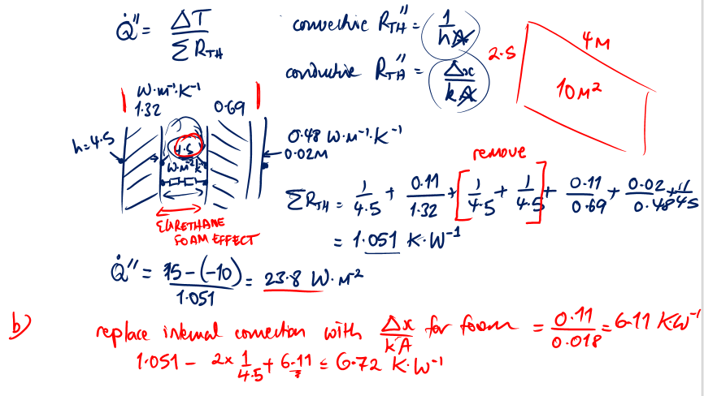

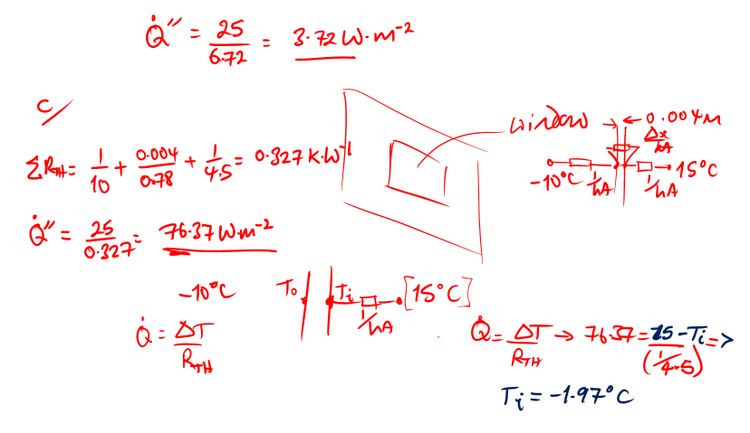

2. Formula for Rth

the maxima and minima are found by differentiation and finding the zero gradients

$$R_{th}=\frac{\ln{\frac{r_{0}}{r_{i}}}}{2πkL}+\frac{1}{hA}$$

therefore:

$$\frac{{dR}_{th}}{dr_{0}}=\frac{d}{{dr}_{o}}\left(\frac{\ln{r_{0}}-\ln{r_{i}}}{2πkL}\right)+\frac{d}{{dr}_{o}}\left(\frac{1}{2πr_{o}Lh}\right)=\frac{\frac{1}{r_{o}}}{2πkL}-\frac{1}{2π{r_{o}}^{2}Lh}$$

For maxima/minima:

$$\frac{\frac{1}{r_{o}}}{2πkL}=\frac{1}{2π{r_{o}}^{2}Lh}→r_{o}=\frac{k}{h}$$

this shows that up to a minimum radius, the insulation makes the heat loss worse.

3. Need to calculate Re first which needs density and viscosity from the tables for air – assume that we can use the dynamic viscosity in the tables as not changed much from the 1 atm pressure air because it is still reasonably low pressure:

calculate density using gas law:

$$ρ=\frac{p}{RT}=\frac{200000}{287×(260+273)}=1.307$$

units m3/kg

dynamic viscosity: 2.849×10-5 kg/ms

Prandtl by the formula for Pr, with cp= 1039.8 J/kgK:

$$Pr=\frac{c_{p}μ}{k}=0.69$$

Pr: 0.69

Re = (1.307×12×0.05)/ 2.849×10-5 = 27534

Nu = 0.023(27534)0.8(0.69)0.4 = 70

use Nu = hd/k, k = 0.043 W/mK

h = 60.7 W/m2K

Then use the thermal resistance combination of the insulation conduction with the internal and external convection, with internal area 2πrL = 0.34 m2, and area outer 0.94 m2

units K/W

Therefore

$$\dot{Q}=\frac{260-15}{2.511}=97.6$$

units W

U based on ri? use the formula relating U and Rth

units W/m2K

4. look for a solution using the Nu correlation and relationship between h and Nu, start with the Gr:

$$Gr=\frac{gβL^{3}∆T}{ν^{2}}$$

Find Tfilm (average of surface and far temperature) = (70+15)/2 = 42.5°C or 315 K (approximate to 325 K in tables to save a bit of time in consolidation session, but could interpolate for data)

From tables at 325 K:

ν=1.568×10-5 m2/s, Pr = 0.71, therefore GrPr =

$$GrPr=\frac{9.81×1/315×{0.05}^{3}(70-15)}{{1.568×10}^{2}}×0.71=8547$$

$$\overline{{Nu}_{d}}={\left\{0.6+\frac{0.387{\left(8547\right)}^{1/6}}{{\left[1+{\left(0.71\right)}^{9/{16}}\right]}^{8/{27}}}\right\}}^{2}=4.2$$

then use Nu = hd/k, with k = 2.816×10-2 W/mK to give:

units are W/m2K

heat transfer is:

$$\dot{Q^{'}}=hA∆T=2.36×2π×0.006×\left(70-15\right)=4.9$$

units W/m