DRAFT-28/2/23
The University of Nottingham

DEPARTMENT OF MECHANICAL, MATERIALS AND MANUFACTURING ENGINEERING

A LEVEL 3 MODULE, SPRING 2023

THERMOFLUIDS 3

Time allowed TWO AND A HALF Hours

- Using the chart in Figure Q1s from the chart page provided, there are two possible angles of the shock wave for the case of supersonic flow at Mach 2 approaching a deflecting wall with angle 15° [1]. The most likely outcome is weak shock at 45±1° [1], because weak shock is statistically more likely. The new Mach number will be from the normal component to the shock wave,
M₁sin45 = 1.414 [1]
And the normal component after the shock will be 0.7355 [1] (from the Table)
Therefore the final Mach number is by geometry:
0.7355/(sin(45-15) = 1.471 [1]. T₂ = 1.2547T₁ = 326 K/53°C [6]

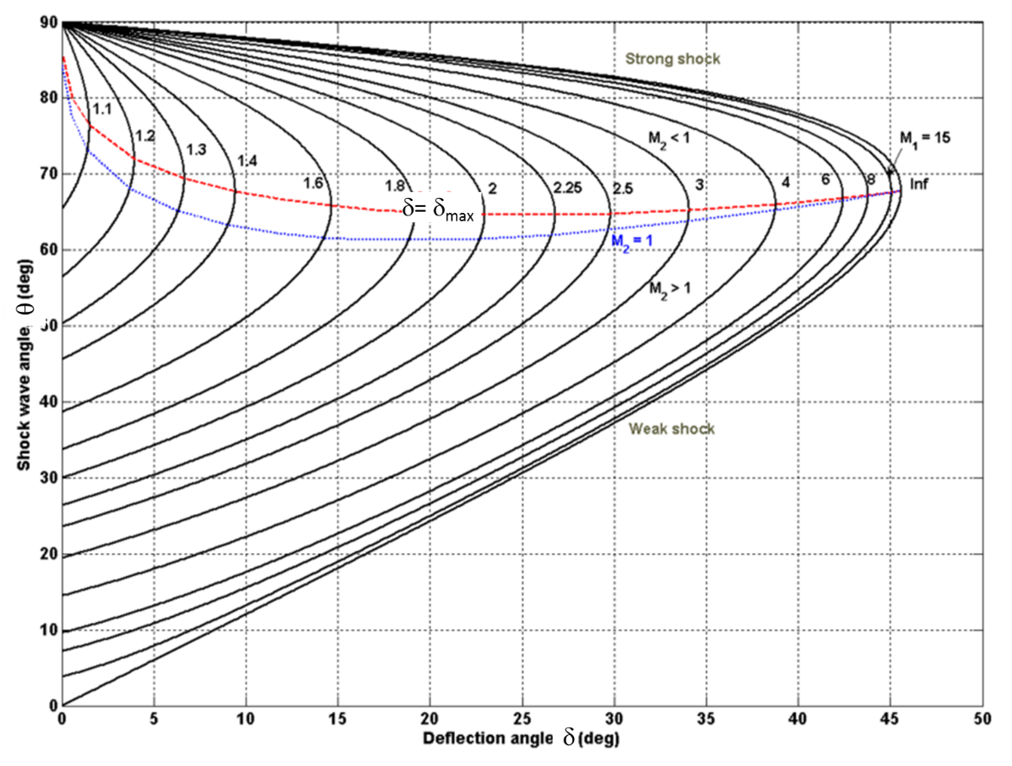
Figure Q1s
2. The Mach number of the flow will increase due to the expansion [1]. Using the expansion fan chart, the starting point at Mach 1.471 has a starting angle of 10±1°. The expansion is 15°, giving a final turned angle of 25±1°. Using the chart, this angle on the curve corresponds to the new Mach number of 2.0±0.1 [2]. Alternative answer using 30° angle is acceptable since not explicitly stated direction, to produce M = 2.7.
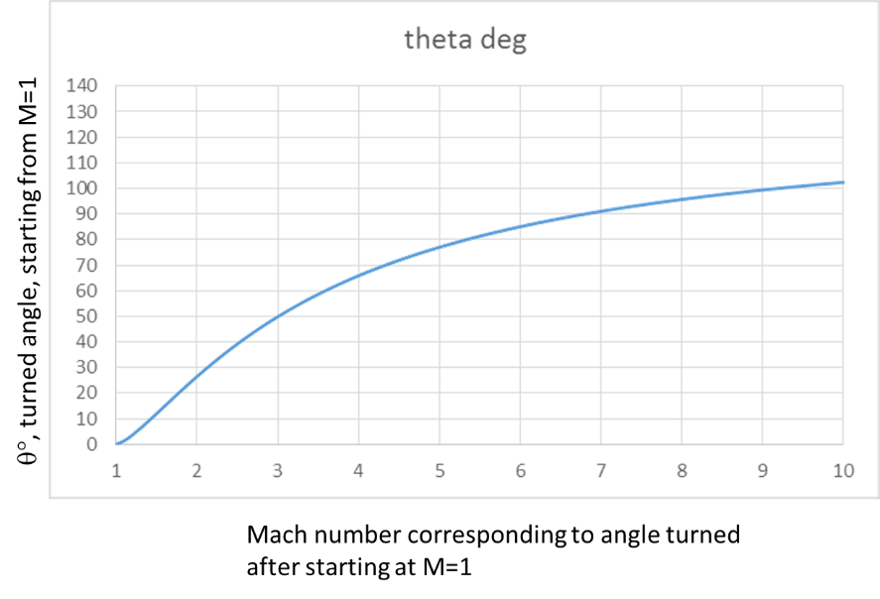
3. (a) Film temperature =(37+17)/2 =27C or 300K (1). At that temperature the air properties are: $Pr=0.707 (1)$, $k=0.0264 W/mK$ (1), $ν=1.568E-5 m^{2}/s$ (1)
(b) We need to find the value of $x_{c}$ where $Re_{x_{c}}<4000$.(2)
$$Re_{x_{c}}<4000=\frac{1*x_{c}}{1.568E-5}→x_{c}=4000*1.568E-5=0.0627m$$
So the flow has become turbulent within 6 cm. So we should use Q3a (1)
(c) Let us calculate the Reynolds number (2).
$$Re_{L}=\frac{1*10}{1.568E-5}=637760$$
WE now have enough to use Q3a to get Nusselt number (2).
$${\overline{Nu}}_{L}=0.037Re_{L}^{\frac{4}{5}}{Pr}^{\frac{1}{3}}=0.037*{\left(637760\right)}^{\frac{4}{5}} {\left(0.707\right)}^{\frac{1}{3}}=1451$$
So now can get heat transfer coefficient(2 +1 for units)
$$h={\overline{Nu}}_{L}*\frac{k}{L}=1451*\frac{0.02624}{10}=3.808 W/m^{2}K$$

(d) 2 marks for replacing Nu and Pr.
$$Sh_{L}=0.037 Re_{L}^{\frac{4}{5}} Sc^{\frac{1}{3}}$$

4. a) Hess’s Law relates the reaction energy to the formation enthalpies of the reactants and products: the difference between the sum of product enthalpies multiplied by their molar proportions and the sum of the reactant enthalpies multiplied by their molar proportions is the reaction energy. In this case the reaction is:
C₂H₄ + 3O₂ → 2CO₂+ 2H₂O [4]
So the sum of product enthalpies is 2*(-393,520)+2*(-241,830) [1] and the sum of the product enthalpies is 52,470 [1]. The difference is therefore: 1,323,170 kJ/kmol [1]. QED.
b) The natural logarithm of the equilibrium constant is equal to the natural logarithm of the ratio of pressures of the products to those of the reactants [3]. In this case e^{1.11} = 3.03, and so the product species have 3 times the pressure of the reactant species [4].

5. (a) simply 10 times the heat loss from area without fins. 1 W. (1)

(b) use trick to differentiate long fin equation (2)
$$\dot{q}=1 W=kA\frac{dθ}{dx}=-kAmθ\left(0\right)$$
Rearrange to get (2 lose mark for no units)
$$m=\frac{1}{-kAθ_{0}}=\frac{1}{\left(200\right)\left(7.07E-6\right)\left(25\right)}=28.3 m^{-1}$$
(c) use definition of m and rearrange to get equation form h (1). Solve (1) and quote units (1)
$$m=\sqrt{\frac{hP}{kA}}→h=\frac{m^{2}kA}{P}=\frac{\left({28.3}^{2}\right)\left(200\right)\left(7.07E-6\right)}{0.0094}=120 W/m^{2}K$$

6.

w₃
c₂

w₂

126 m/s
62°
c₃
77°

314 m/s

[3]
The 50% reaction turbine is symmetrical (approximately, subject to decimal places on beta angles), therefore approximately w₂ = c₃ and w₃ = c₂. The values, w, can be calculated by c_{x}/cosβ. Therefore w₂ = c₃ = 126/cos62 = 268 m/s and w₃ = c₂ = 126/cos77 = 560 m/s. Alternatively by pythogoras this can result in 263 and 565 m/s respectively due to the lack of decimal places on beta angles. [2]

Work:
$$\dot{W}=\dot{m}\left(U_{3}c_{θ3}-U_{2}c_{θ2}\right)=66×314×\left(\left(c_{3}\sin{62}+c_{2}\sin{77}\right)\right)=66×314×\left(236+545\right)$$
$$or 66×314×\left(231+550\right)=16.2 MW in both cases$$
[5]
The amount of velocity slip is due to the blade spacing, s [1], around the circumference related to the axial chord length [1], b, and the flow turning represented by the absolute velocity angles, α. The Zweifel criterion offers a relationship that allows a sensible value of s and b to be determined in relation to the turning angles in order to offer a good compromise between too many blades causing friction, and a low diffusion for more effective flow control and more stage work [1]. [3]

7. The flow of exergy into the steel tube is ${\dot{E}}^{Q}={\dot{Q}}_{1}\left(\frac{\left(T_{1}-T_{0}\right)}{T_{1}}\right)$, ${\dot{E}}^{Q}=120\left(\frac{\left(773-288\right)}{773}\right)=75.3 kW$ [3]

The flow of exergy through the inner side of the steel wall is ${\dot{E}}^{Q}=120\left(\frac{\left(723-288\right)}{723}\right)=72.2 kW$ [3]

Therefore rate of exergy loss is 3.1 kW/m². [2]

8. (a) $F_{AB}=0.3$ is given. Can deduce $F_{AA}=0$, so $F_{AC}$=0.7 (1)
Can deduce $F_{BB}=0$, $F_{BA}=\frac{A_{A}}{A_{B}} F_{AB}=0.4775$, so $F_{BC}=1-F_{BA}-F_{BB}=0.5225$ (1.5)
$F_{CB}=\frac{A_{B}}{A_{C}}F_{BC}=0.1492$, $F_{CA}=\frac{A_{A}}{A_{C}}F_{AC}=0.3182$, so $F_{CC}=1-F_{CA}-F_{CB}=0.5326$ (1.5)

(b)

$$σT_{A}^{4}$$
$$σT_{C}^{4}$$
$$σT_{B}^{4}$$
$$J_{A}$$
$$J_{B}$$
$$J_{C}$$
$$R_{B}$$
$$R_{C}$$
$$R_{A}$$
$$R_{BC}$$
$$R_{AB}$$
$$R_{AC}$$
3 marks for black body potentials. 3 marks for all Radiosities. 3 marks for all resistors. 1 mark for using correct lettering as asked. [10]

9. Mass flow rate is 30 kg/s
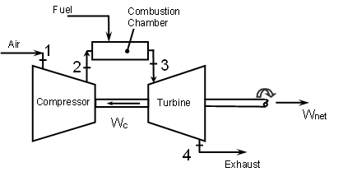

In turbine
$T_{4}=T_{3}{\left(\frac{p_{4}}{p_{3}}\right)}^{\frac{\left(η_{∞t}\right)\left(γ-1\right)}{γ}}$

$T_{4}={(1400+273)\left(\frac{1}{10}\right)}^{(\frac{0.9(1.33-1)}{1.33})}$
T₄ = 1000 K (727°C) [5 marks]
(A more accurate answer is by using 1.333, producing 996.9 K.)
So work output from turbine is $\dot{m}c_{p}(T_{3}-T_{4})$ = 30×1.13(1400-727)
= 22,815 kW [5 marks]
[10]

Approach steam temperature is 727-120 = 607°C or 880 K, T_{sat} = 234°C, enthalpy at approach point is close to 600°C = 3682 kJ/kgK [2]; and at pinch point, h_{sat} = 1008 kJ/kgK [1]. Therefore the flow rate of steam is given by the thermal energy exchange between the steam: $\dot{m}(3682-1008)$ [2]
And the gases: $30×1.13×\left(727-\left(234+15\right)\right)=16,204$ kW [2]
Therefore $\dot{m}$=16,204/2674 = 6.06 kg/s. [1]
[8]
END

